# General

This Technical Reference explains the use of the Standards & Conformance Department NMRA Template to create documents. It is based on that template itself. Many fields are automatically filled in from the document properties.

# Standards & Conformance Department Documents

The NMRA Executive Handbook[1] (EHB) is the guiding document for the operation of the NMRA. The Standards & Conformance Department section outlines the responsibilities of the Standards & Conformance Department and documents the department is responsible for.

## Document Types

The Standards & Conformance Department maintains many types of documents; the most visible are the NMRA Standards (S) and Recommended Practices (RP), which define the requirements for NMRA Conformance.

|  |  |  |
| --- | --- | --- |
| **Type** | **Description** | **Public** |
| Standard (S) | Define mandatory requirements for NMRA Conformance. | Yes |
| Recommended Practice (RP) | Define optional requirements for NMRA Conformance. | Yes |
| Technical Note (TN) | Clarify the thought process behind the contents of Standards and Recommended Practices. | Yes |
| Technical Information (TI) | Contain supplemental information that may be of interest. TI documents are the equivalent of the NMRA Data Sheets (maintained by the Education Department). | Yes |
| Technical Procedure (TP) | Test plans which contain the procedures and checklists for determining if a particular product conforms to the Standards and Recommended Practices. | Yes |
| Technical Equipment | Describe the theory and construction of Conformance and Inspection test equipment. | Yes |
| Technical Reference (TR) | For the use of the Standards & Conformance Department and general membership, and contain formulas and department procedures. Historically, many TR’s were published in the NMRA Bulletin and are somewhat public. | No |

## Document Numbering Conventions

| **Type** | **Numbering Convention** |
| --- | --- |
| Standard (S) | S-n |
| Recommended Practice (RP) | RP-n |
| Technical Note (TN) | TN-n |
| Technical Information (TI) | TI-n |
| Technical Procedure (TP) | TP-n |
| Technical Equipment | TE-n-yyyy |
| Technical Reference (TR) | TR-n-yyyy |

## Document Phases

A document must undergo several phases during its development.

|  |  |  |  |  |  |  |  |
| --- | --- | --- | --- | --- | --- | --- | --- |
| **Phase** | **S** | **RP** | **TN** | **TP** | **TI** | **TE** | **TR** |
| Draft | X | X | X | X | X | X | X |
| Department Chair Approval | X | X | X | X | X | X | X |
| Published for Comment | X | X |  |  |  |  |  |
| Proposed | X | X |  |  |  |  |  |
| Board of Directors Approval | X | X |  |  |  |  |  |

## File Naming Conventions

Each document is named by its Document Number followed by the document title. The term “Draft” should not be in the filename. If the document is a draft, then the “Draft” suffix shall only be added to the document property field for “Title”, see section 3 below.

Upon publication, a date suffix may optionally be added to the filename. This may aid archival tracking and publishing of specific revisions of a given document to the NMRA website.

# Setting the Document Properties

The template uses Word “Quick Parts” for the visible document property fields. The advantage of this is that the text can be edited inline, and all other locations where the same “Quick Part” field is used within the document will automatically be updated. The document property fields are found in the first page header and each page footer of the template.

The following document property fields should be updated when a document is newly created from the template:

| **Property** | **Template Starting Value** | **Values**  **(Using This Document as an Example)** |
| --- | --- | --- |
| Title | X-9.99.99 Draft[2] | TR-1-2020 |
| Subject | Brief Desc. | S & C Documents and Formatting |
| Company | © yyyy – yyyy[3] National Model Railroad Association, Inc. | © 2020 National Model Railroad Association, Inc. |

Additionally, the template contains two invisible document properties. In Microsoft Word 2010, these document properties can be found under the **File** tab. Choose the **Info** section on the left toolbar. On the bottom of the right hand pain, choose the option **Show All Properties**. Update the following document properties:

| **Property** | **Template Starting Value** | **Values**  **(Using This Document as an Example)** |
| --- | --- | --- |
| Manager | Carl Smeigh | Carl Smeigh |
| Author | Stuart Baker | Stuart Baker |

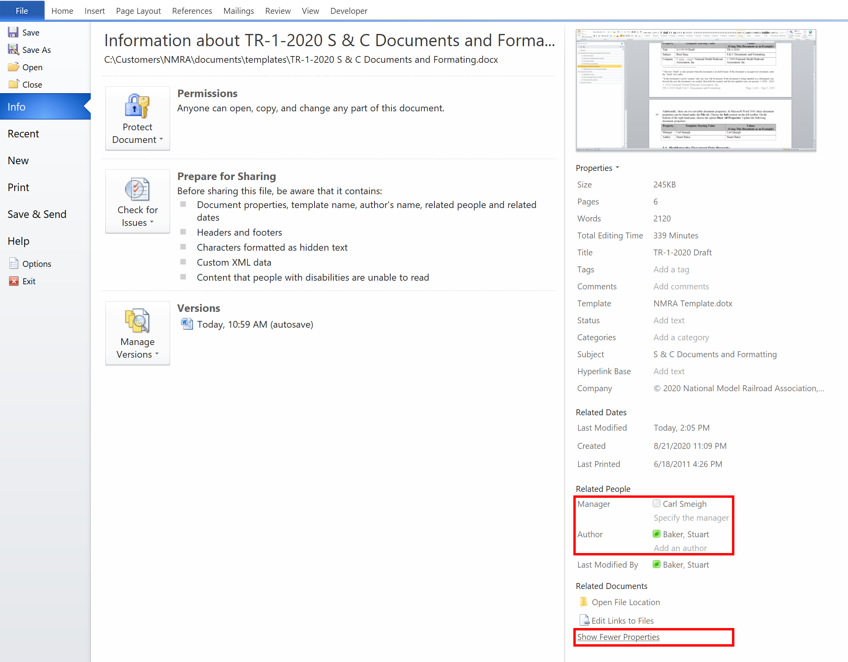

## Modifying the Document Date Property

The Document date can be found in the upper right corner of the first page header. It is also found on the lower right hand corner footer on every page. The standard document property field of “Publish Date” is used, and is designed for manual update.

The “Published Date” field can be updated by clicking on any of the date fields in the document and choosing a new date from the pop up calendar. Changing any one of the document date fields should result in all of the document date fields being changed.

The date shall be manually updated to the current date at the following times:

1. When sending the document out for a formal review. Reviewers shall note the date of the document under review when providing their feedback.
2. Prior to sending the document out for final voting approval if, and only if, changes have been made since the last formal review.

The date may optionally be manually updated to the current date at the following times:

1. Whenever the document is edited.

The date shall not be updated after voting approval. The only change to the document after voting approval and before publishing shall be to remove the “Draft” suffix to the “Title” document property.

# Document Contents

Each document should have a short introductory paragraph describing the contents and related documents, i.e. other Standards, Recommended Practices, Technical Notes, etc…

Each top-level document heading should be identical between Standards, Recommended Practices, Technical Notes, etc… to aid in cross-referencing documents.

## Standards Content

The NMRA EHBi describes Standards as:

NMRA Standards Shall be limited to only those things that are critical to the satisfactory operation (function) and interchange of equipment between layouts, and for which no satisfactory alternative is available.

It further describes the following criteria for inclusion:

* That it will include all dimensional and other requirements to effect interchange and satisfactory performance.
* That it will exclude all not so required.
* That it be accurate and clearly stated.

## Recommended Practice Content

The NMRA EHB describes Recommended Practices as follows:

Recommended Practices shall define and SPECIFY the dimensional and configuration requirements and/or symbols pertaining to model railroad construction, equipment, and supplies to facilitate improve performance and interchange of components within uints.

It further states:

Recommended Practices shall conform to and supplement appropriate standards.

## Technical Note Content

The Standards and Conformance Department describes Tech Technical Notes as companion documents to Standards & RPs to communicate complex reasoning and departmental thoughts on particular parts of Standard and RP sections.

# Document History

|  |  |
| --- | --- |
| **Date** | **Description** |
| Sep 9, 2020 | First revision. |

**Important Notices and Disclaimers Concerning NMRA Standards Documents**

The Standards (S), Recommended Practices (RP), Technical Note (TN), and Technical Information (TI) documents of the National Model Railroad Association (“NMRA Standards documents”) are made available for use subject to important notices and legal disclaimers. These notices and disclaimers, or a reference to this page, appear in all standards and may be found under the heading "Important Notices and Disclaimers Concerning NMRA Standards Documents."

**Notice and Disclaimer of Liability Concerning the Use of NMRA Standards Documents**

NMRA Standards documents are developed within the Standards and Conformance Department of the NMRA in association with certain Working Groups, members, and representatives of manufacturers and sellers. NMRA develops its standards through a consensus development process, which brings together volunteers representing varied viewpoints and interests to achieve the final product. NMRA Standards documents are developed by volunteers with modeling, railroading, engineering, and industry-based expertise. Volunteers are not necessarily members of NMRA, and participate without compensation from NMRA.

NMRA does not warrant or represent the accuracy or completeness of the material contained in NMRA Standards documents, and expressly disclaims all warranties (express, implied and statutory) not included in this or any other document relating to the standard or recommended practice, including, but not limited to, the warranties of: merchantability; fitness for a particular purpose; non-infringement; and quality, accuracy, effectiveness, currency, or completeness of material. In addition, NMRA disclaims any and all conditions relating to results and workmanlike effort. In addition, NMRA does not warrant or represent that the use of the material contained in NMRA Standards documents is free from patent infringement. NMRA Standards documents are supplied “AS IS” and “WITH ALL FAULTS.”

Use of NMRA Standards documents is wholly voluntary. The existence of an NMRA Standard or Recommended Practice does not imply that there are no other ways to produce, test, measure, purchase, market, or provide other goods and services related to the scope of the NMRA Standards documents. Furthermore, the viewpoint expressed at the time that NMRA approves or issues a Standard or Recommended Practice is subject to change brought about through developments in the state of the art and comments received from users of NMRA Standards documents.

In publishing and making its standards available, NMRA is not suggesting or rendering professional or other services for, or on behalf of, any person or entity, nor is NMRA undertaking to perform any duty owed by any other person or entity to another. Any person utilizing any NMRA Standards document, should rely upon their own independent judgment in the exercise of reasonable care in any given circumstances or, as appropriate, seek the advice of a competent professional in determining the appropriateness of a given NMRA Standards documents.

IN NO EVENT SHALL NMRA BE LIABLE FOR ANY DIRECT, INDIRECT, INCIDENTAL, SPECIAL, EXEMPLARY, OR CONSEQUENTIAL DAMAGES (INCLUDING, BUT NOT LIMITED TO: THE NEED TO PROCURE SUBSTITUTE GOODS OR SERVICES; LOSS OF USE, DATA, OR PROFITS; OR BUSINESS INTERRUPTION) HOWEVER CAUSED AND ON ANY THEORY OF LIABILITY, WHETHER IN CONTRACT, STRICT LIABILITY, OR TORT (INCLUDING NEGLIGENCE OR OTHERWISE) ARISING IN ANY WAY OUT OF THE PUBLICATION, USE OF, OR RELIANCE UPON ANY STANDARD OR RECOMMENDED PRACTICE, EVEN IF ADVISED OF THE POSSIBILITY OF SUCH DAMAGE AND REGARDLESS OF WHETHER SUCH DAMAGE WAS FORESEEABLE.

**Translations**

NMRA’s development of NMRA Standards documents involves the review of documents in English only. In the event that an NMRA Standards document is translated, only the English version published by NMRA is the approved NMRA Standards document.

**Official Statements**

A statement, written or oral, that is not processed in accordance with NMRA policies for distribution of NMRA communications, or approved by the Board of Directors, an officer or committee chairperson, shall not be considered or inferred to be the official position of NMRA or any of its committees and shall not be considered to be, nor be relied upon as, a formal position of NMRA.

**Comments on Standards**

Comments for revision of NMRA Standards documents are welcome from any interested party, regardless of membership. However, **NMRA does not provide interpretations, consulting information, or advice pertaining to NMRA Standards documents.**

Suggestions for changes in documents should be in the form of a proposed change of text, together with appropriate supporting comments. Since NMRA standards represent a consensus of concerned interests, it is important that any responses to comments and questions also receive the concurrence of a balance of interests. For this reason, NMRA, its departments, Working Groups or committees cannot provide an instant response to comments, or questions except in those cases where the matter has previously been addressed. For the same reason, NMRA does not respond to interpretation requests. Any person who would like to participate in evaluating comments or in revisions to NMRA Standards documents may request participation in the relevant NMRA working group.

**Laws & Regulations**

Users of NMRA Standards documents should consult all applicable laws and regulations. Compliance with the provisions of any NMRA Standards document does not constitute compliance to any applicable regulatory requirements. Implementers of the standard are responsible for observing or referring to the applicable regulatory requirements. NMRA does not, by the publication of NMRA Standards documents, intend to urge action that is not in compliance with applicable laws, and NMRA Standards documents may not be construed as doing so.

**Copyrights**

NMRA Standards documents are copyrighted by NMRA under US and international copyright laws. They are made available by NMRA and are adopted for a wide variety of both public and private uses. These include both use, by reference, in laws and regulations, and use in private self-regulation, standardization, and the promotion of modeling, structural and engineering practices and methods. By making NMRA Standards documents available for use and adoption by public authorities and private users, NMRA does not waive any rights in copyright to the NMRA Standards documents.

**IMPORTANT NOTICE**

NMRA Standards documents do not guarantee or ensure safety, security, health, or environmental protection, or ensure against interference with or from other systems, devices or networks. NMRA Standards documents development activities consider research and information presented to the standards development group in developing any safety recommendations. Other information about safety practices, changes in technology or technology implementation, or impact by peripheral systems also may be pertinent to safety considerations during implementation of the standard. Implementers and users of NMRA Standards documents are responsible for determining and complying with all appropriate safety, security, environmental, health, and interference protection practices and all applicable laws and regulations.

1. NMRA Executive Handbook, Section Q1.1, Rev 10/29/2010
2. The text “Draft” is only present when the document is in draft format. If the document is an approved document, omit the “Draft” text suffix.
3. If the document is newly created, only one year will be present. If the document is being updated in a subsequent year beyond the year the document was created, then both the creation and the last updated years are present: © 2020 – 2021.